RAJALAKSHMI ENGINEERING COLLEGE

# RAJALAKSHMI NAGAR, THANDALAM – 602 105



|  |
| --- |
| **CS23A34**  **USER INTERFACE AND DESIGN LAB** |
| **Laboratory Observation NoteBook** |

**Name :** SRIVATHSAN N

**Year/Branch/Section :** II/CSE/F **Register No. :** 230701343 **Semester :** IV

**Academic Year:** 2024-25

**Ex. No. : 4a Date:12/2/25**

**Register No. : 230701343 Name : Srivathsan N**

**Conduct task analysis for an app (e.g., online shopping) and document user flows. Create corresponding wireframes using Lucidchart**

# Aim:

To understand and document the steps a user takes to complete the main tasks within an online shopping app.

# Procedure:

**Step 1: Assigning Tasks**

1. Browsing Products
2. Searching for a Specific Product
3. Adding a Product to the Cart
4. Checking Out

# Step 2: Document User Flows

1. Browsing Products
   1. Home Screen: User lands on the home page with product categories.
   2. Product Categories: User taps on a category to view products.
   3. Product List: User scrolls through the product list.
   4. Product Details: User taps on a specific product to see details. Home Screen -> Product Categories -> Product List -> Product Details
2. Searching for a Specific Product
   1. Search: User taps the search bar or icon.
   2. Enter Query: User types the product name or keyword.
   3. Search Results: User reviews matching items.
   4. Product Details: User taps on a specific product to see details. Search -> Enter Query -> Search Results -> Product Details
3. Adding a Product to the Cart
   1. View Products: User browses or searches for a product.
   2. Product Details: User taps on the product to see more info.
   3. Add to Cart: User clicks "Add to Cart". View Products -> Product Details -> Add to Cart
   4. Checking Out
      1. Open Cart: User taps on the cart icon.
      2. Review Cart: User checks all products.
      3. Proceed to Checkout: User clicks "Checkout".
      4. Enter Shipping Info: User provides shipping details.
      5. Enter Payment Info: User provides payment details.
      6. Place Order: User clicks "Place Order".

Open Cart -> Review Cart -> Proceed to Checkout -> Enter Shipping Info -> Enter Payment Info -> Place Order

# Step-by-Step Procedure to Create User Flows in Lucidchart

1. Create a New Document
   * Go to Lucidchart and sign in or sign up if you don't have an account.
   * Click on + Document or Create New Diagram.
2. Select a Template
   * You can start with a blank document or select a flowchart template.
   * For this example, let's start with a blank document.
3. Add Shapes for Each Step
   * Drag and drop shapes from the left sidebar to represent different steps in your flow (e.g., rectangles for actions, diamonds for decisions).
   * Name each shape based on the steps from the task analysis:
     + Login/Register
     + Browsing Products
     + Adding Products to Cart
     + Managing Cart
     + Checkout Process
     + Tracking Orders
4. Connect the Shapes
   * Use connectors to link the shapes, indicating the flow from one step to the next.
   * Add arrows to show the direction of the flow.
5. Add Details to Each Step
   * Double-click on each shape to add text describing the action or decision.
   * For example, for the "Login/Register" step, you might add:
     + Open the app
     + Click on "Sign Up" or "Login"
     + Enter details (username, email, password)
     + Click "Submit"
     + Verification through email or phone (if required)
     + Redirect to the home screen upon successful login
6. Use Different Shapes for Different Actions
   * Use rectangles for general actions.
   * Use diamonds for decision points (e.g., "Is the user logged in?").
   * Use ovals for start and end points.
7. Customize and Organize Your Flowchart
   * Arrange the shapes and connectors logically.
   * Use different colors to distinguish between types of steps or user roles.
   * Group related steps into sections for better clarity.
8. Review and Save Your Flowchart
   * Review the flowchart to ensure all steps are included and connected correctly.
   * Save your flowchart by clicking on File -> Save.
9. Share and Collaborate
   * Click on the Share button to collaborate with others.
   * You can also export your flowchart as an image or PDF for presentation purposes.

# Example Flowchart Breakdown:

Login/Register Flow

* + Steps:
    - Open the app
    - Click on "Login" or "Register"
    - Enter details
    - Verify (if required)
    - Redirect to the home screen Browse and Search Flow
  + Steps:
    - Navigate to categories or use search bar
    - Apply filters/sorting options
    - View product details Add to Cart Flow
  + Steps:
    - View product details
    - Select options (size, color, quantity)
    - Add product to cart

Checkout Flow

* + Steps:
    - Review cart
    - Proceed to checkout
    - Enter shipping information
    - Select payment method
    - Confirm and place order Order Tracking Flow
  + Steps:
    - Navigate to "My Orders"
    - Select order to track
    - View tracking details

# Output:

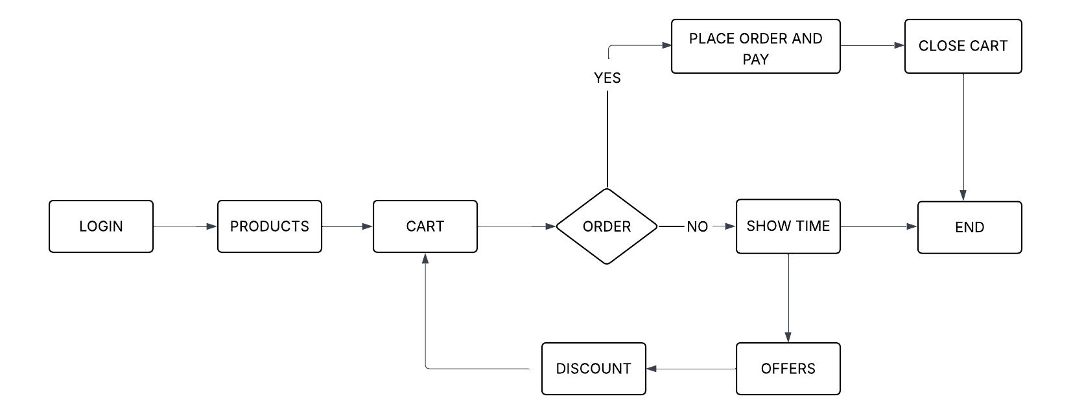

**Result:**

Hence conducted the task analysis for an app (e.g., online shopping) and documented the user flows. Created corresponding wireframes using Lucidchart has been successfully done.